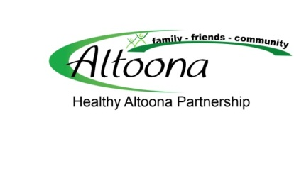
A FREE Service provided by The Healthy Altoona Partnership can assist employers to make healthier choices possible for their employees in a number of ways that do not need to be a cost to the company. This service will help show you that Health Promotion does not need to be expensive and does not always mean paying for wellness programs. It can be as easy as acknowledging that May is National Employee Health and Fitness Month by hosting walk over lunch or a break; or a healthy potluck.
According to the Public Health Institute, “Boosting employee health translates into a healthier bottom line. In fact, reducing health risk factors including weight, blood pressure, glucose and cholesterol by just 1 percent would save as much as $103 annually in medical costs per person, much of which would return to employers through reduced premiums.”
This organization also stated that, “Businesses with a healthier workforce see cost savings including: Reduced costs of employee health care benefits and workers’ compensation; increased worker productivity; decreased absenteeism; and increased retention and employee job satisfaction.”
Services that the Healthy Altoona Partnership can offer include:
- Assessment of the worksite and policies that affect or influence health
- Evaluating vending machine options and making suggestions for changes that would include some healthy options and would identify the healthier options.
- Tobacco cessation resources provided by the American Lung Association
- Assistance to develop embedded strategies into your existing wellness programs that will make them more sustainable
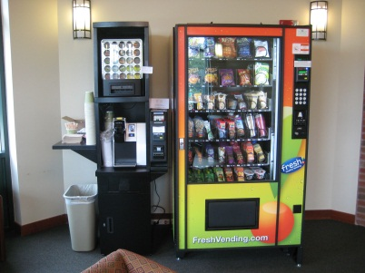
To access this service, contact Marcia Roth at Marcia.roth@msn.com or Keith Hyland at keithhyland@gmail.com

